Project Design Phase-II
Technology Stack (Architecture & Stack)
Date | 3 October 2026
Team ID | SWTID-2026-3373
Project Name | Import Data using Transform Maps (Spreadsheet)
Maximum Marks | 4 Marks

Technical Architecture:
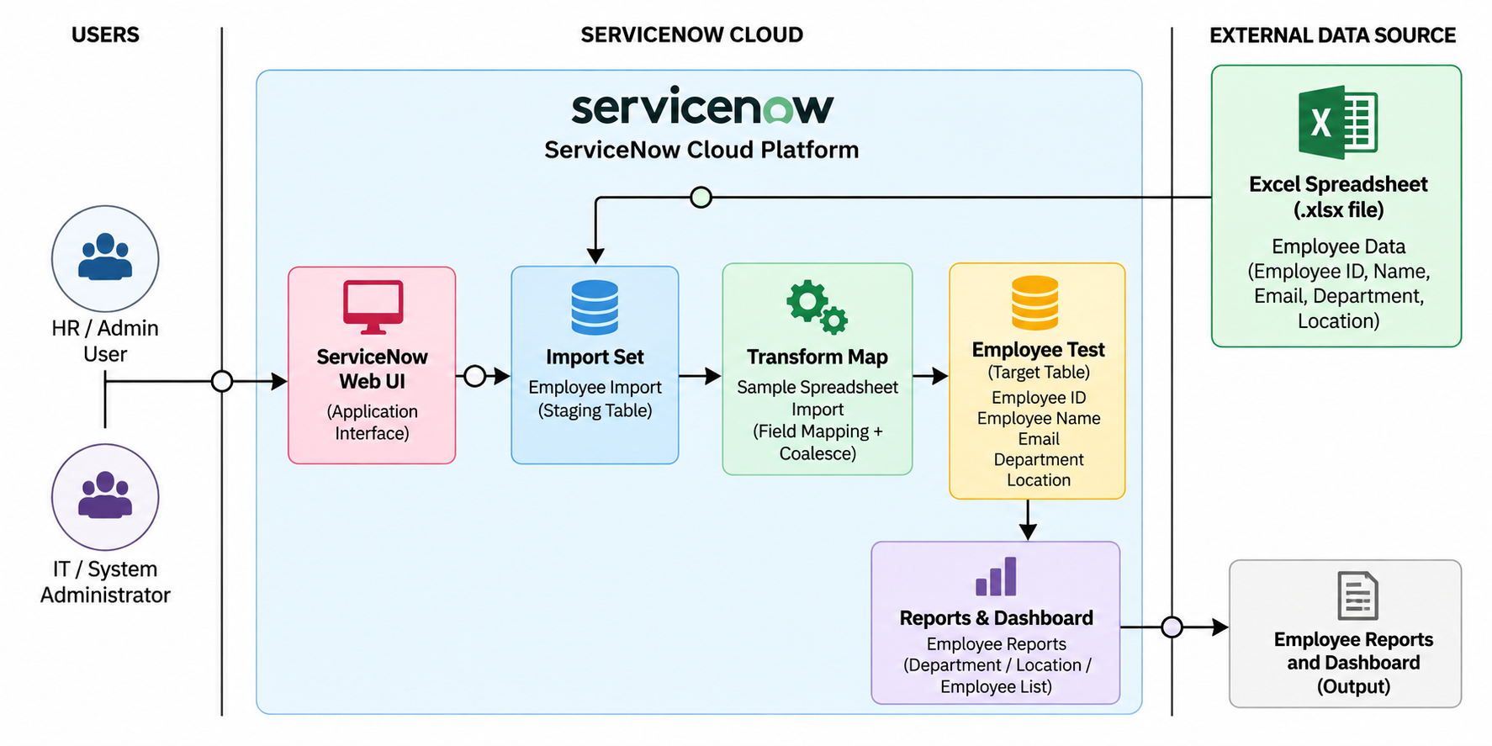
Table-1 : Components & Technologies:
S.No | Component | Description | Technology
1 | User Interface | Interface used by HR/Admin users to manage and view employee data | ServiceNow Web UI
2 | Application Logic-1 | Create and manage employee records | ServiceNow Platform / Custom Table
3 | Application Logic-2 | Import employee spreadsheet data into staging table | ServiceNow Import Sets
4 | Application Logic-3 | Map and transform source data into employee records | ServiceNow Transform Maps
5 | Database | Stores employee records and application data | ServiceNow Database
6 | Cloud Database | Cloud-based storage provided by the ServiceNow platform | ServiceNow Cloud Database
7 | File Storage | Temporary spreadsheet file used for employee data import | Excel (.xlsx) / Local File
8 | External API-1 | Not required for the project | Not Applicable
9 | External API-2 | Not required for the project | Not Applicable
10 | Machine Learning Model | No machine learning model is used | Not Applicable
11 | Infrastructure (Server / Cloud) | Hosts the ServiceNow application and database | ServiceNow Cloud Platform

Table-2: Application Characteristics:
S.No | Characteristics | Description | Technology
1 | Open-Source Frameworks | No external open-source framework is required. The solution uses the ServiceNow platform. | ServiceNow Platform
2 | Security | Employee data is accessible to authorized ServiceNow users through platform access controls. | ServiceNow Access Controls / ACLs
3 | Scalable Architecture | Import Sets and Transform Maps allow employee spreadsheets to be processed repeatedly and records to be transformed into the target table. | ServiceNow Import Sets & Transform Maps
4 | Availability | The application is hosted on the ServiceNow cloud platform and can be accessed through the ServiceNow instance. | ServiceNow Cloud Platform
5 | Performance | Bulk employee data can be loaded through Import Sets and transformed using a Transform Map instead of entering records manually. | Import Sets & Transform Maps

